**DAILY ONLINE ACTIVITIES SUMMARY**

|  |  |  |  |  |  |  |  |
| --- | --- | --- | --- | --- | --- | --- | --- |
| **Date:** | **26/05/2020** | | | | **Name:** | **Anusha. K** | |
| **Sem & Sec** | **4th SEM 'A' Section** | | | | **USN:** | **4AL18CS009** | |
| **Online Test Summary** | | | | | | | |
| **Subject** | | **Design and analysis of algorithms** | | | | | |
| **Max. Marks** | | **30** | | **Score** | | **27** | |
| **Certification Course Summary** | | | | | | | |
| **Course** | **Introduction to ethical hacking** | | | | | | |
| **Certificate Provider** | | | **greatlearning academy** | **Duration** | | | **6 hours** |
| **Coding Challenges** | | | | | | | |
| **Problem statement 1:**Write a program in c to print all permutations of a given string using array.  **Problem statement 2:**Given an array A of size N where the array elements contain values from 1 to N with duplicates, the task is to find total number of subarrays which start and end with the same element.  Problem statement 3:Write a JAVA Program to remove all the Tens in the given array | | | | | | | |
| **Status: completed** | | | | | | | |
| **Uploaded the report in Github** | | | | **yes** | | | |
| **If yes Repository name** | | | | [**https://github.com/anusha20219/Lockdown-coding**](https://github.com/anusha20219/Lockdown-coding) | | | |
| **Uploaded the report in slack** | | | | **yes** | | | |

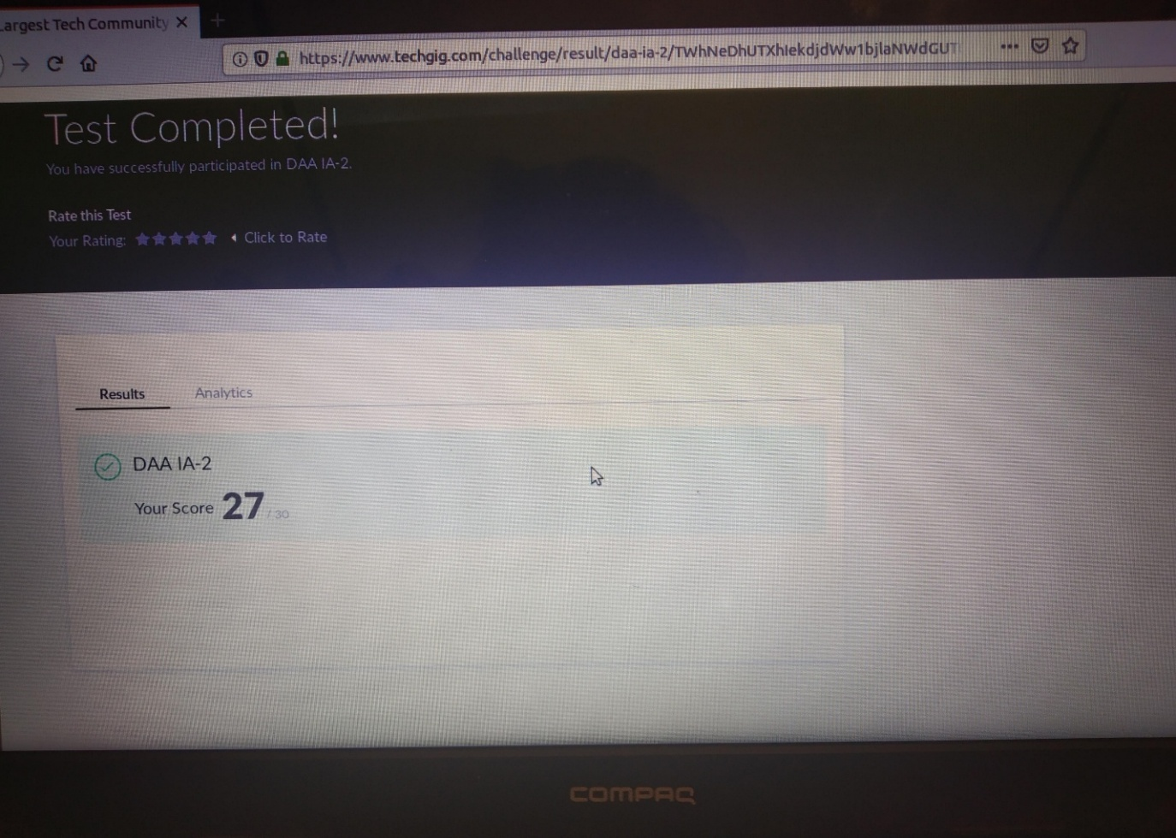

**ONLINE TEST DETAILS:** DAA test was scheduled from 9:15 am to 10:00am .The portion for the IA was 2nd module there were 30 questions and the time assigned was 45 minutes the questions were mcq type.

**CERTIFICATION COURSE DETAILS: topics covered are**

* Career and growth ladder in ethical hacking
* Domains and process implementation under ethical hacking
* Ethical hacking in network demonstration

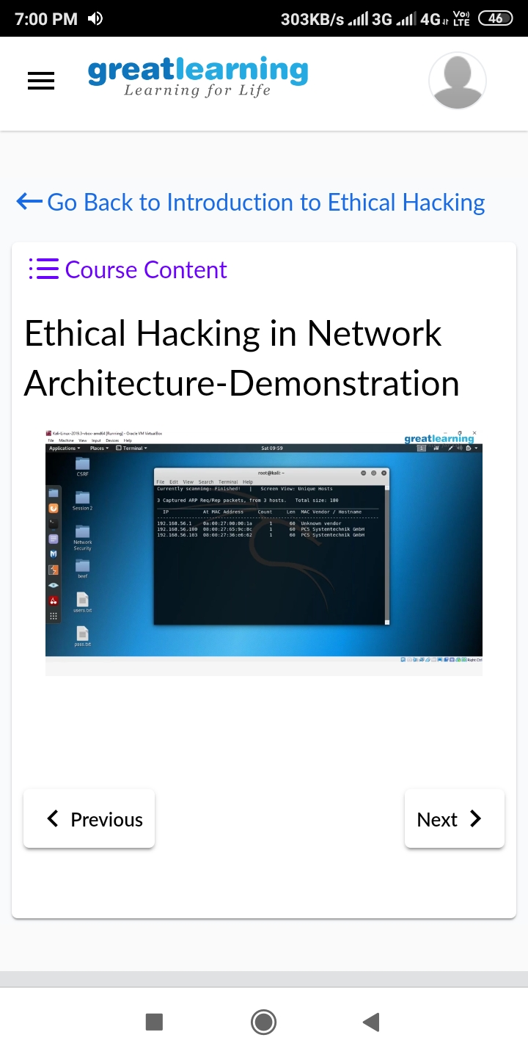

**CODING CHALLENGES DETAILS**:

**Problem statement 1:** Write a program in c to print all permutations of a given string using array.

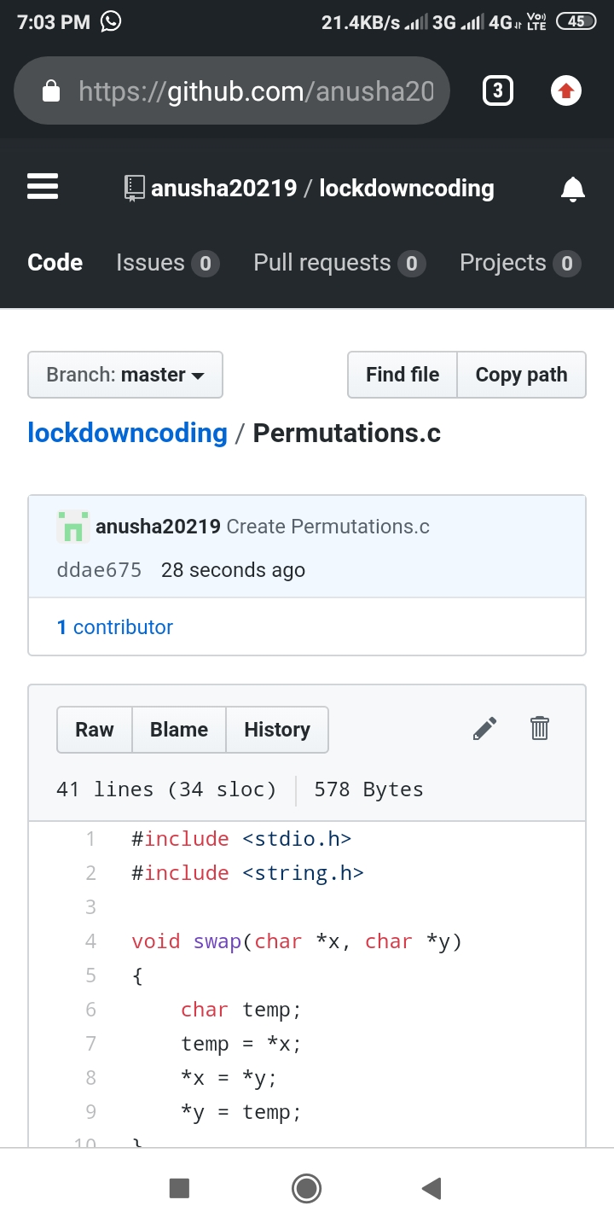

**Problem statement 2**:Given an array A of size N where the array elements contain values from 1 to N with duplicates, the task is to find total number of subarrays which start and end with the same element.

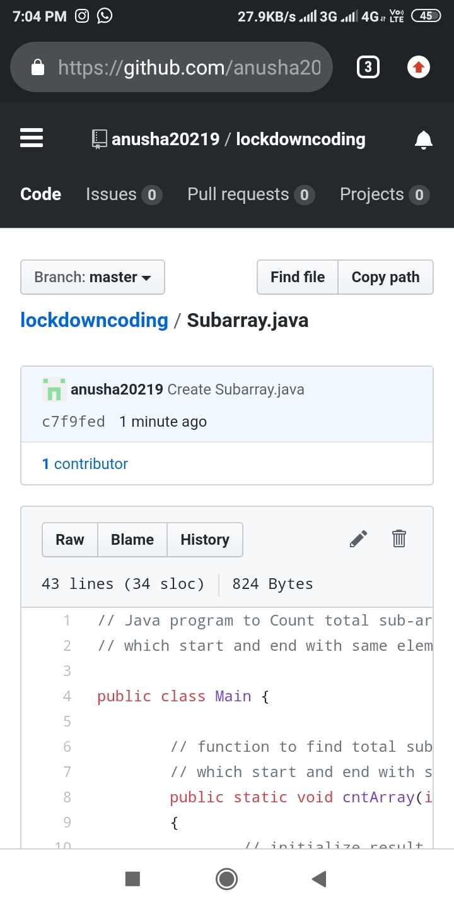

Problem 3:

Write a JAVA Program to remove all the Tens in the given array

Return a version of the given array where all the 10’s have been removed. The remaining elements should shift left towards the start of the array as needed, and the empty spaces a the end of the array should be 0. So {1, 10, 10, 2} yields {1, 2, 0, 0}. You may modify and return the given array or make a new array.

Example

withoutTen([1, 10, 10, 2]) → [1, 2, 0, 0]

withoutTen([10, 2, 10]) → [2, 0, 0]

Input: First line should read number of array elements. Second Line should read the array elements which includes atleast two 10.

Output: Array which contains elements without 10. Refer the examples

